**Promotion management System**

Chonlapat Muksakun 5804062660184

Thasaran Bunrueng 5804062660231

Phanuruj Kondo 5804062663116

Kittiphat Ammuang 5804062660010

Sirin Surarangsan 5804062663175

**Overall**

This project focus on managing shopping promotion to connect with user by letting user to search the promotion by their own or connect the promotion that concerned with bank credit card to the credit card that users are holding.

**Requirement**

There are two types of user. First is Customer user and second is Business owner user. Customer user is a user that register to our system only for searching promotion. user has user_id, user_fname, user_lname, user_email, user_password. shop is a user that has shop of his own and register their shop to our system. They must be user before they can register their shop. So, the shop has shop_id, shop_name, shop_opendate, shop_opentime, shop_closetime. user must hold the type_card (user can hold more than one type of card and each type of card are held by many user). type_card must have type_id and type_name. the user have to fill in their information about the card that they are holding. Those information is card_no, card_name, exp. Our system will detect the type_card automatically from card_no. and connect to the type_card. The card must belong to the bank to screening the promotion that support this bank because some promotion has not support every bank. the bank must have bank_id and bank_name. The type_card Must support the promotion (card can support many promotion and one promotion can be supported to many cards). This relation means “what card that supporting the promotion”. The promotion has pro_id, pro_name, descrition, pro_startdate, pro_enddate, pro_img. The promotion must have category to specify the type of promotion and for easiness to search and modify. The category must have c_id and c_name. The promotion has relation with shop entity called own. This relation means “what shop that own the promotion”. The shop has relation with User (Business owner user) called register. This relation means “who is the business owner user that register this shop”.

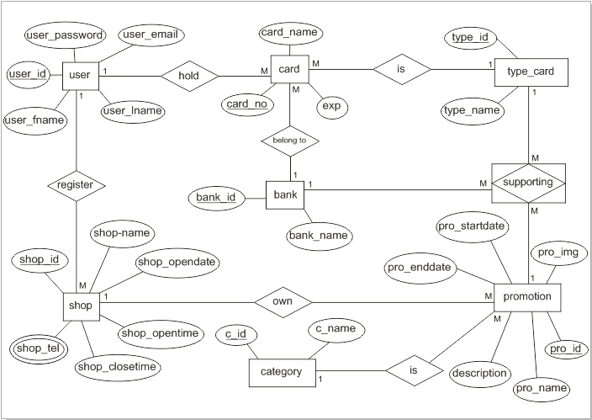**ER-diagram**

**Note** → primary key , *foreign key

**Relation Schema of ER**

user(user_id, user_fname, user_lname, user_email, user_password)

bank (bank_id, bank_name)

type_card (type_id, type_id)

category (c_id, c_name)

card (card_no, card_name, exp, *user_id, *type_id, *bank_id)

shop (shop_id, shop_name, shop_opendate, shop_opentime,

shop_closetime, *user_id)

shoptelphone (*shop_id, shop_tel)

promotion (pro_id, pro_name, description, pro_startdate, pro_enddate, pro_img, *shop_id, *c_id)

supporting (*pro_id, *card_id, *bank_id)

**Relation Schema of 1NF**

user (user_id, user_fname, user_lname, user_email, user_password)

bank (bank_id, bank_name)

type_card (type_id, type_id)

category (c_id, c_name)

card (card_no, card_name, exp, *user_id, *type_id, *bank_id)

shop (shop_id, shop_name, shop_opendate, shop_opentime,

shop_closetime, *user_id)

shoptelphone (*shop_id, shop_tel)

promotion (pro_id, pro_name, description, pro_startdate, pro_enddate, pro_img, *shop_id, *c_id)

supporting (*pro_id, *card_id, *bank_id)

**partial dependency**

-None

**Relation Schema of 2NF**

user(user_id, user_fname, user_lname, user_email, user_password)

bank (bank_id, bank_name)

type_card (type_id, type_id)

category (c_id, c_name)

card (card_no, card_name, exp, *user_id, *type_id, *bank_id)

shop (shop_id, shop_name, shop_opendate, shop_opentime,

shop_closetime, *user_id)

shoptelphone (*shop_id, shop_tel)

promotion (pro_id, pro_name, description, pro_startdate, pro_enddate, pro_img, *shop_id, *c_id)

supporting (*pro_id, *card_id, *bank_id)

**transitive dependency**

-None

**Relation Schema of 3NF**

user(user_id, user_fname, user_lname, user_email, user_password)

bank (bank_id, bank_name)

type_card (type_id, type_id)

category (c_id, c_name)

card (card_no, card_name, exp, *user_id, *type_id, *bank_id)

shop (shop_id, shop_name, shop_opendate, shop_opentime,

shop_closetime, *user_id)

shoptelphone (*shop_id, shop_tel)

promotion (pro_id, pro_name, description, pro_startdate, pro_enddate, pro_img, *shop_id, *c_id)

supporting (*pro_id, *card_id, *bank_id)

**Data dictionary**

